Bad Toy Design
( contributed by Josephine Banyard, DVM)
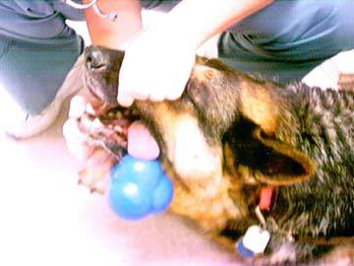

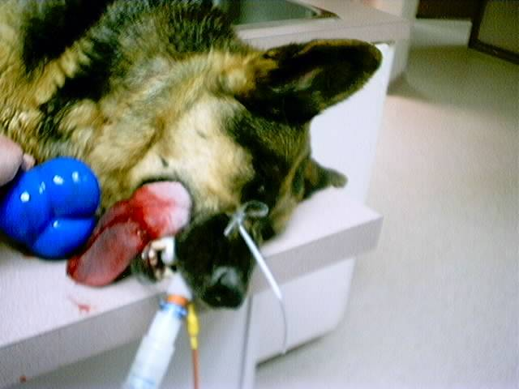

I came to the clinic on my day off only to find our AHT escorting a very cute German shepherd, Abbey, into the clinic. I couldn't figure out why our AHT was looking so serious when Abbey was carrying her toy into the clinic. What a clever dog, I thought.
Appearances can be deceiving. The owners had noticed her carrying the toy around the night before and thought she was playing with her toy. The next day it was still in her mouth. On closer inspection, they realized it was stuck on her tongue.
We removed it under anesthetic. Fortunately, we did not have to remove any of her tongue, as about half of the tongue was inside the toy. If we had had to amputate she would have had very serious difficulties in drinking and eating. She has lost small portions of her tongue but she will be ok.
We believe the problem is one of design. There is no hole at the end of this toy resulting in suction on the tongue. When the owners notified the company of this case, the unconcerned representative of the company who made the toy told them that this is not a toy but something, which is designed to hold dog food, which the animal then rolls around so that the food drops out for the dog to then eat. They said the package states that this should always be used under supervision. Abbey, of course, did not understand this concept.
Do not assume that the toys you buy for your pets are safe. Think safety as you buy. Knowing how pets eat, lick, and swallow, try to think of strange ways your pet can use and abuse the toy before buying it. Try and think like your pet.

