Canine Influenza (Dog Flu)

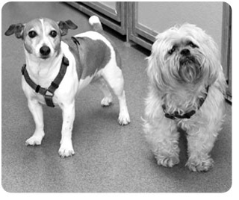
What is canine influenza?
Canine influenza is a highly contagious respiratory infection of dogs caused by influenza H3N8 virus. In 2003 it was recognized in Florida Greyhound Kennels, which shared facilities with horses. Within 2 years it was identified as causes of outbreaks in kennels, veterinary hospitals, and shelters throughout the country.

Interestingly stored blood samples indicate it was present in the Greyhound population for almost 10 years prior to recognition, with the illnesses it caused probably attributed to other or to unidentified upper respiratory organisms.
Just like human flu, dog flu is very contagious. Because of the lack of previous exposure to this virus, dogs have no natural immunity so that all dogs dog exposed to it will become infected. About 80% of infected dogs will show signs of infection, and those that don’t can still spread the virus to other dogs.
What are the signs?
The most common sign of dog flu is a persistent cough. There are at least seven respiratory organisms that can cause similar upper airway signs. This similarity can make it hard to diagnose which illness a dog has without the cost and turn around time of PCR testing.
About 80% of dogs that show signs will have a mild flu. Signs in this case include a low-grade fever, running nose, lack of energy, loss of appetite, and a cough that can last up to a month. The unfortunate minority can be prone to developing secondary pneumonia, making this a serious disease. The fatality rate of dogs that develop pneumonia secondary to canine influenza can reach 50 percent if not given proper treatment.
Risks for infection can be from direct contact, coughing, sneezing, and contaminated objects. Dogs of all ages and breeds are susceptible. Dogs that are groomed, boarded, go to obedience classes or attend Doggie Day care are at increased risk, but even casual meeting on dog walks can transmit this disease.
Protection: Vaccination
With risk related to exposure to other dogs it is now our policy that all dogs Boarding or attending Doggie Day Care at Goldens Bridge Veterinary Care Center should be vaccinated.
The Canine Influenza vaccine from has been proven to significantly reduce the severity and duration of canine influenza; it does not prevent all disease, but does prevent severe disease. The initial studies published in over 700 dogs have shown the vaccine to be safe and effective. The vaccine has now been used in thousands of dogs with very few adverse reactions.
The initial vaccination requires 2 doses, 2–4 weeks apart, followed by annual revaccination. It takes 10 days from the booster vaccine for full immunity to develop.

If your dog is being vaccinated for Kennel Cough (Bordetella), he/she is a likely candidate for Canine Influenza Vaccine.
Our staff and/or our veterinarians will be happy to answer questions about this disease. Other sources can be found online at:

♦ doginfluenza.com
- ♦avma.org/public_health/influenza/canine_bgnd.asp
♦ http://www.veterinarypartner.com/Content.plx?P=A&S=0&C=0&A=2165

